Learning Mac Automator

link: macmostvideo

Heading 1

Heading 2

Heading 3

Heading 4

How to set an alarm on mac
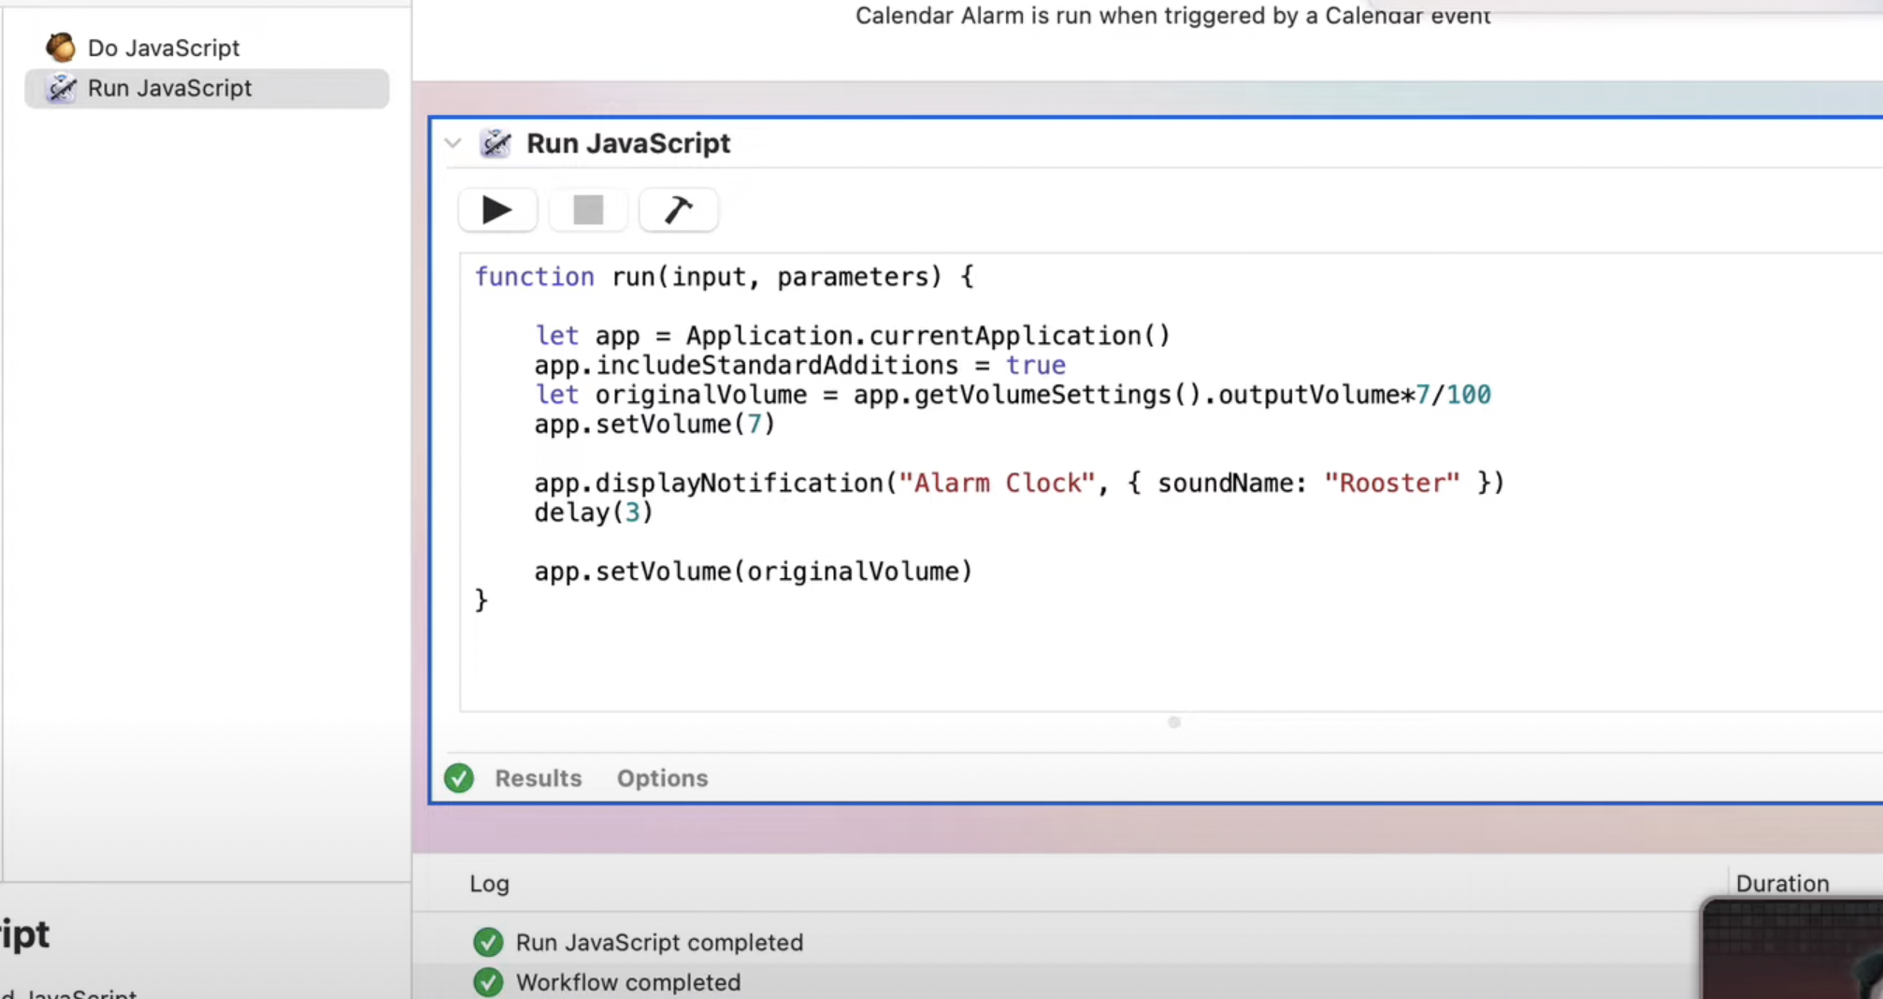
1. Something to trigger this things.
2. So we can do scripting

To find the sounds:
goto finder → go → press option key → libraries → Sound → add an audio

How to change file creation date to match file metadata
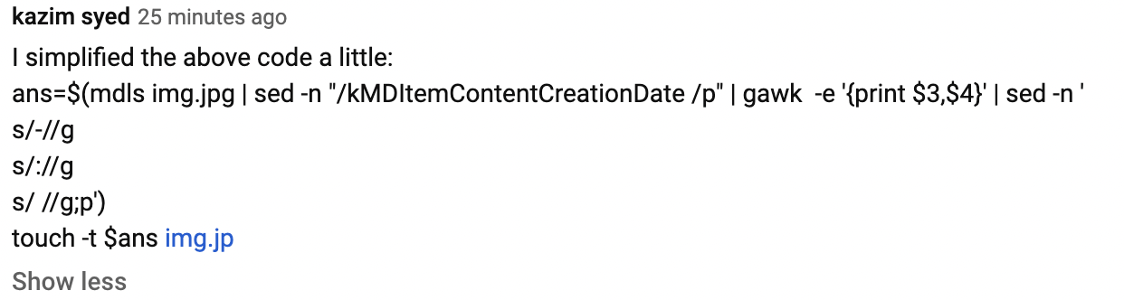
Create an application:
and go for arguments it will gimme a loop.
Cause u wanna perform a batch process.

Look at the new shortcuts App for mac
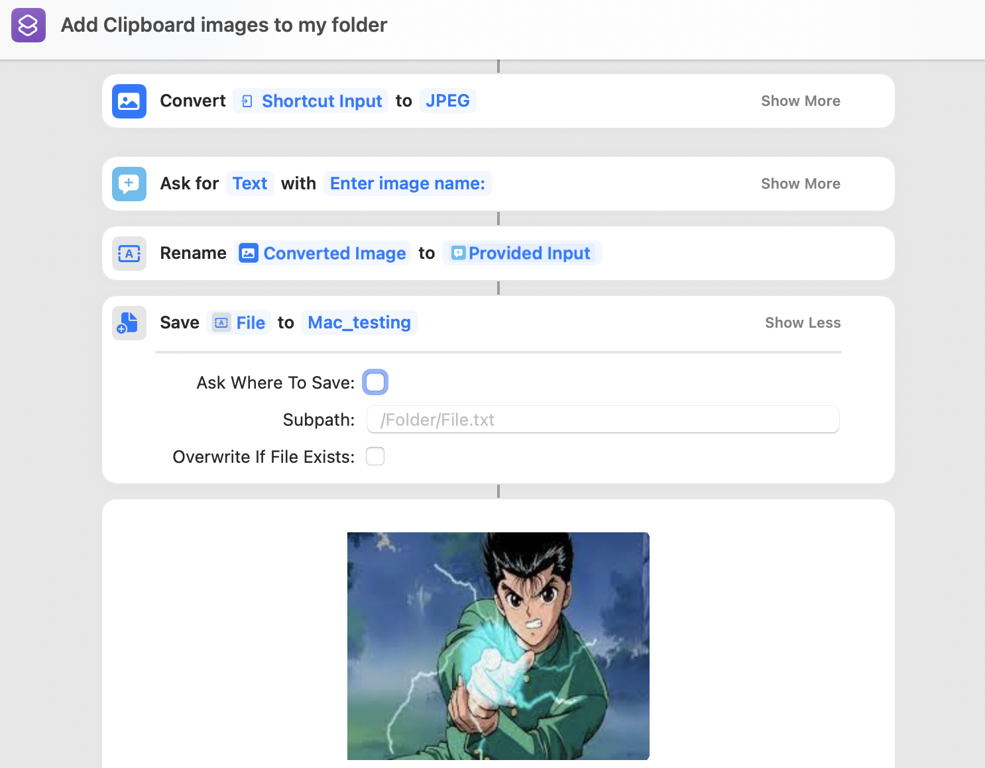

You can access it :
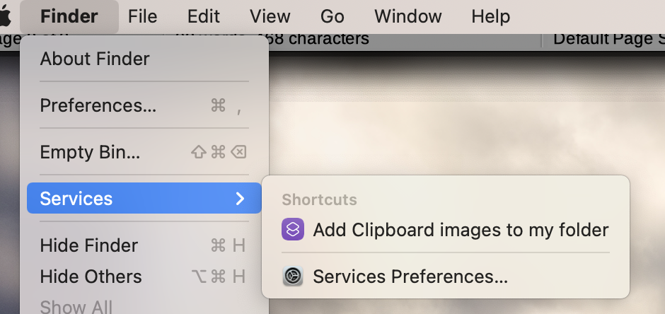

(2)
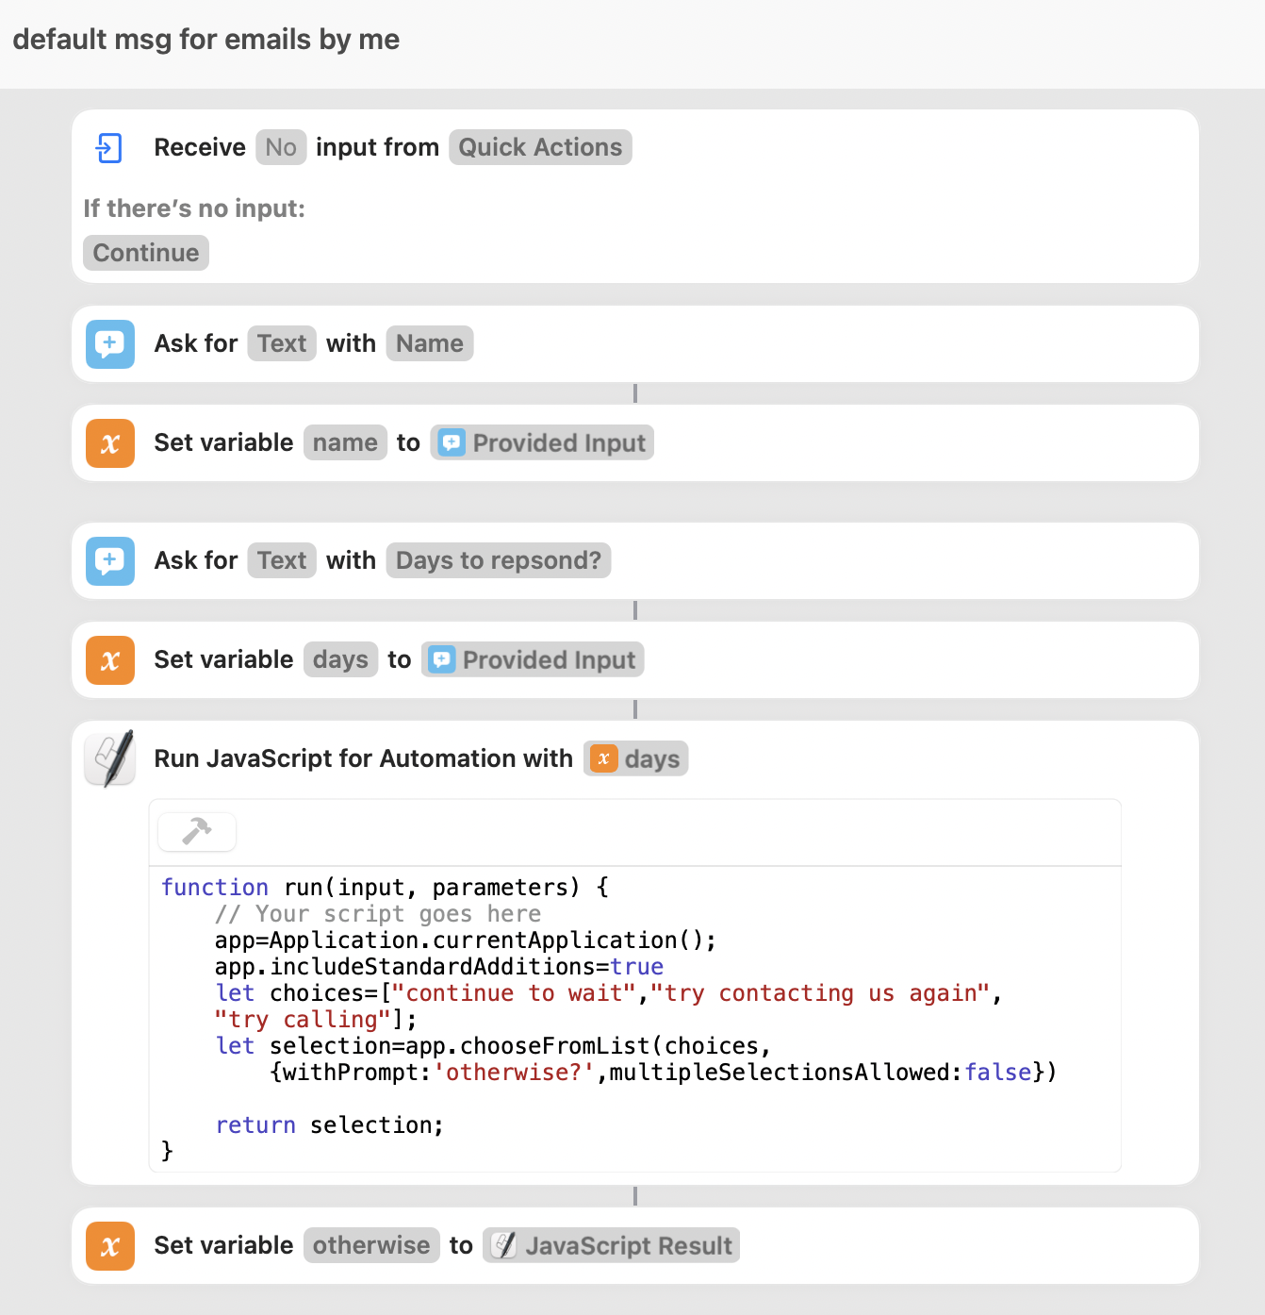

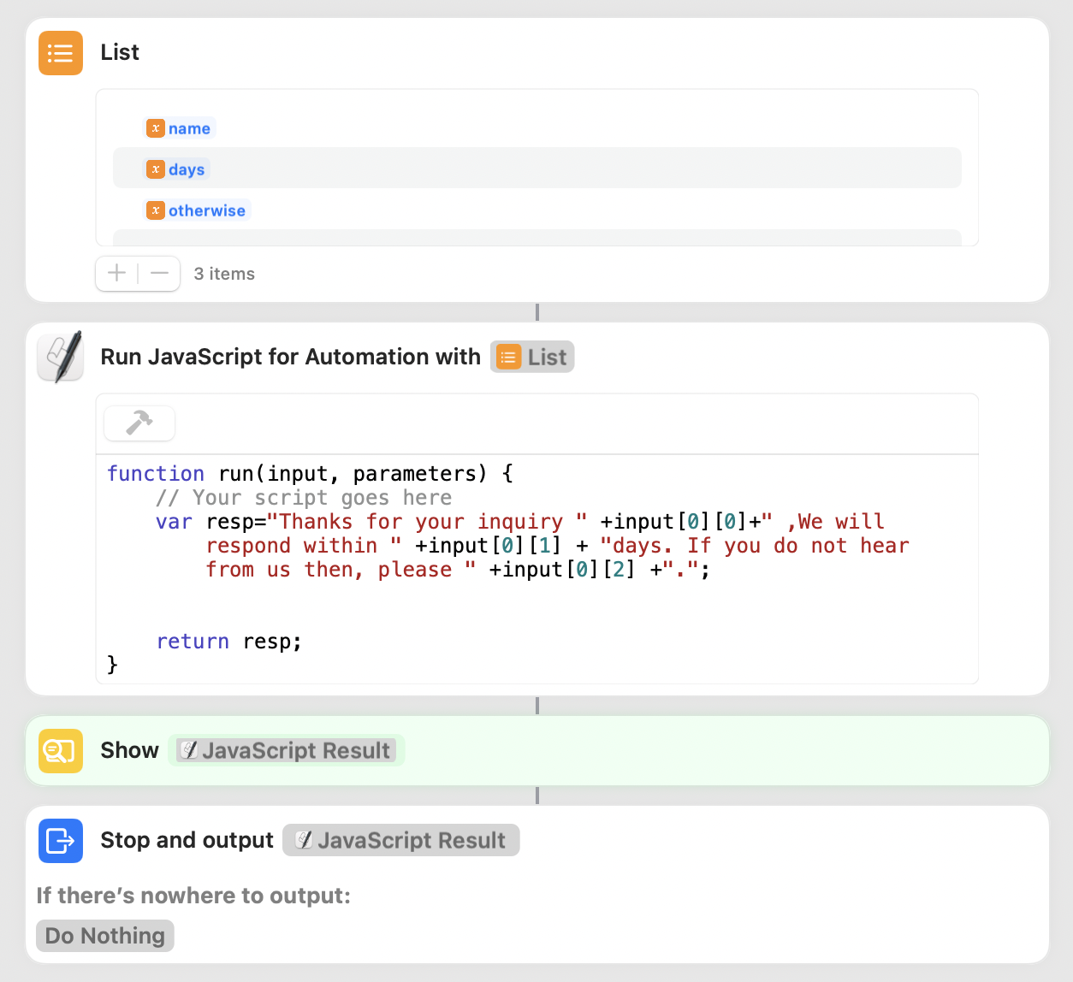

output:
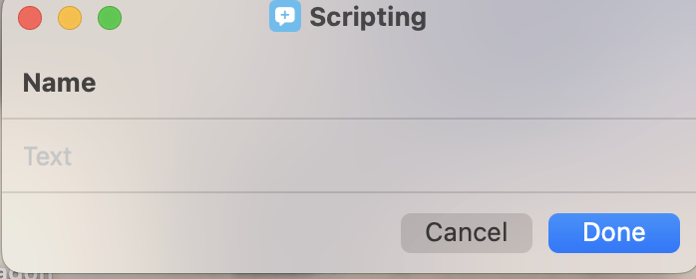

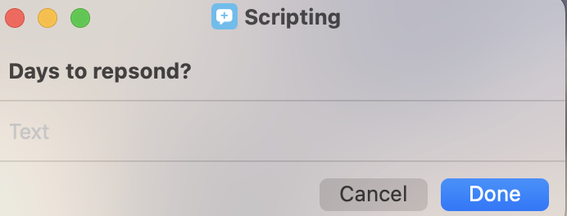

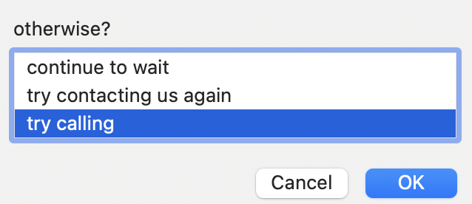


(3)
Keep in Menu bar makes it easily accessible.
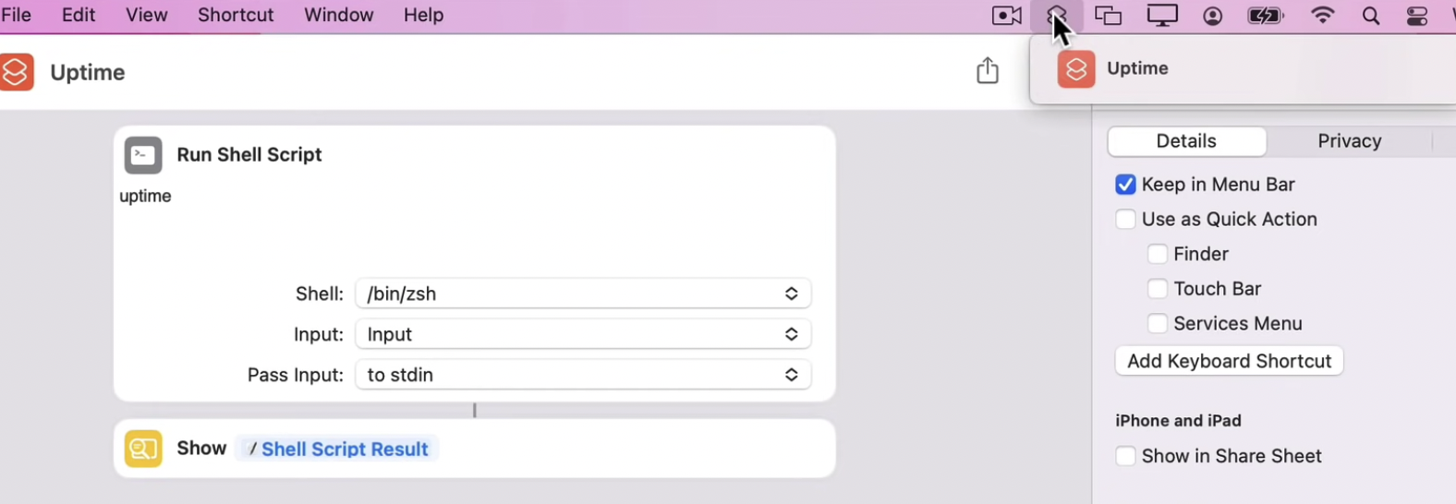

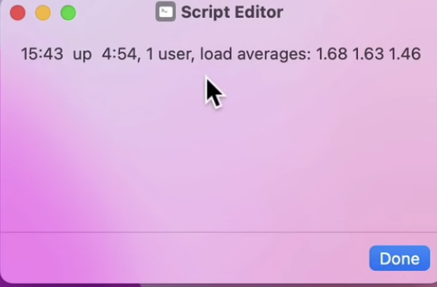

--

Creating an information notification with shell script and automator
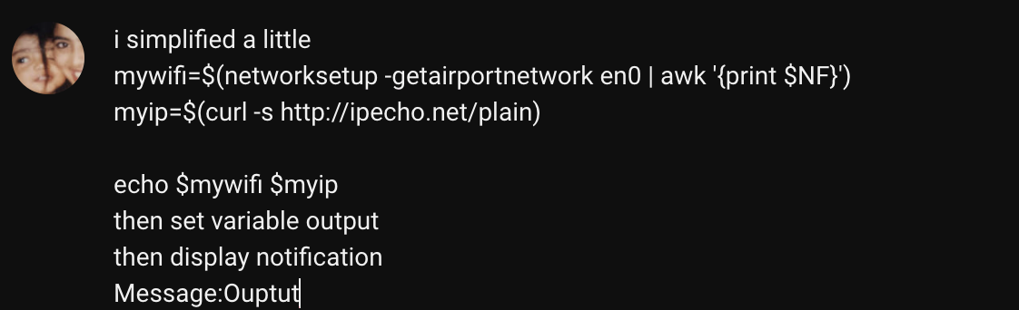
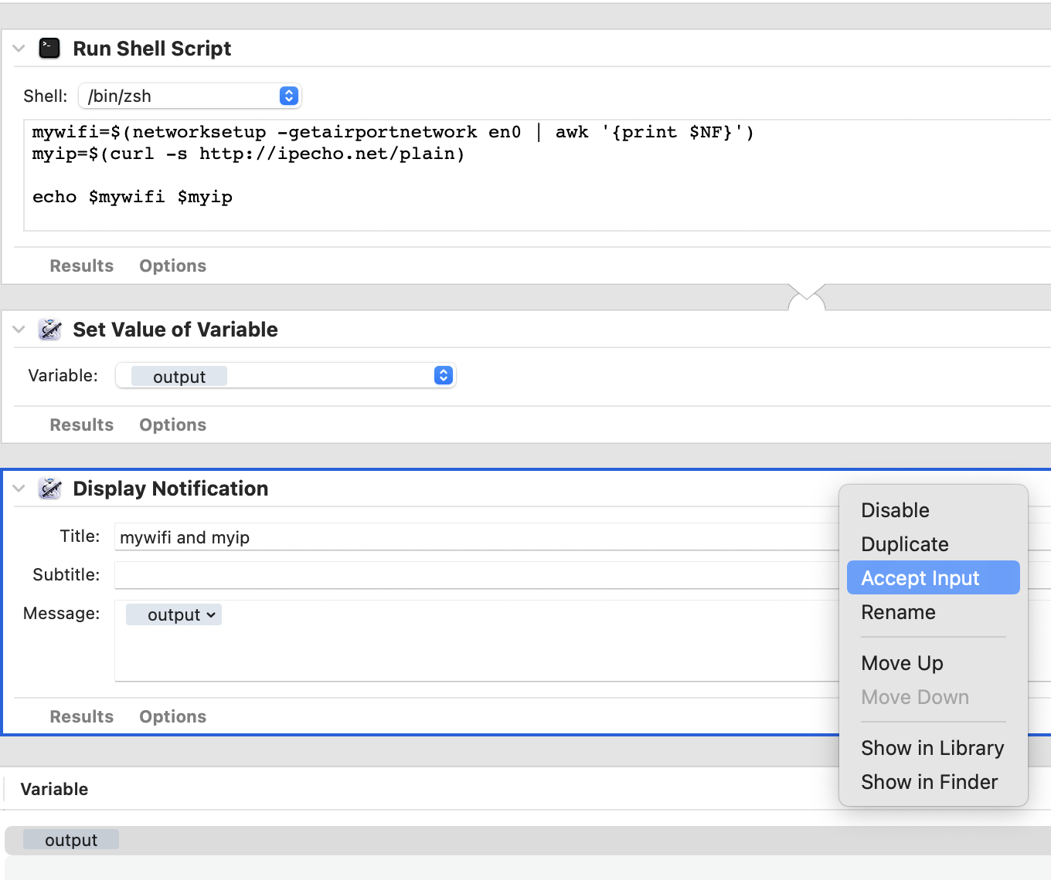Figure 1: Here, i ignored input

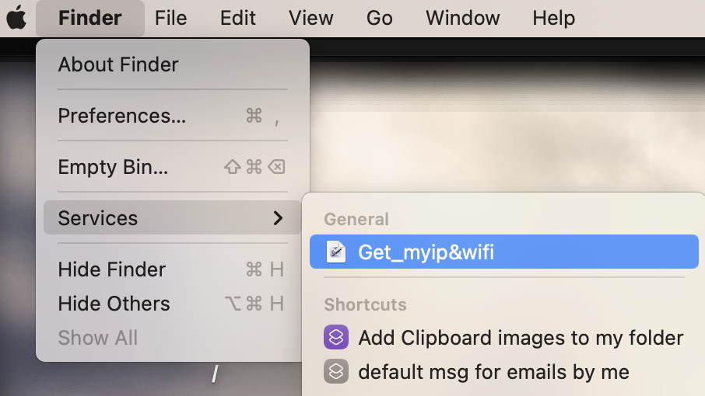

You can also set shortcuts for services.
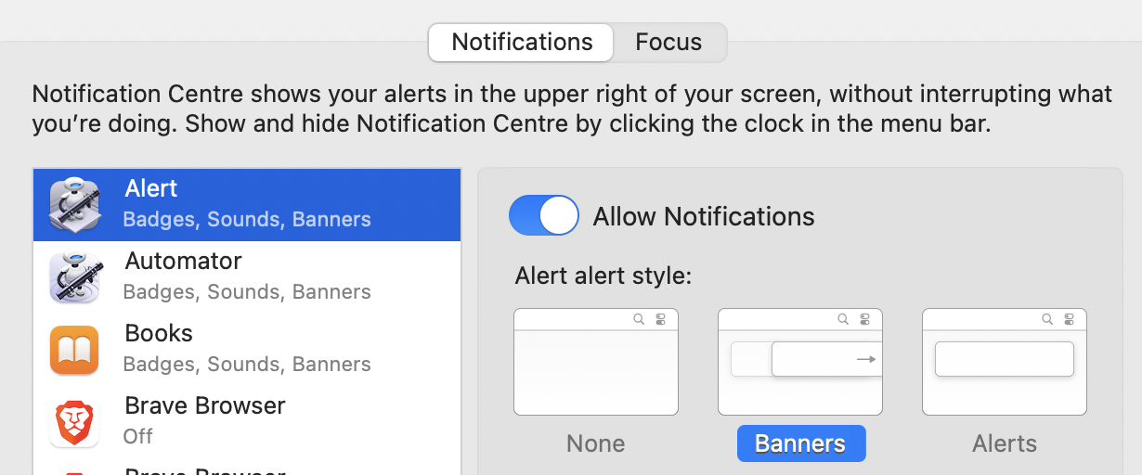

You can also adjust how ur notification appears.

Two ways to quickly switch between light and dark mode in mac
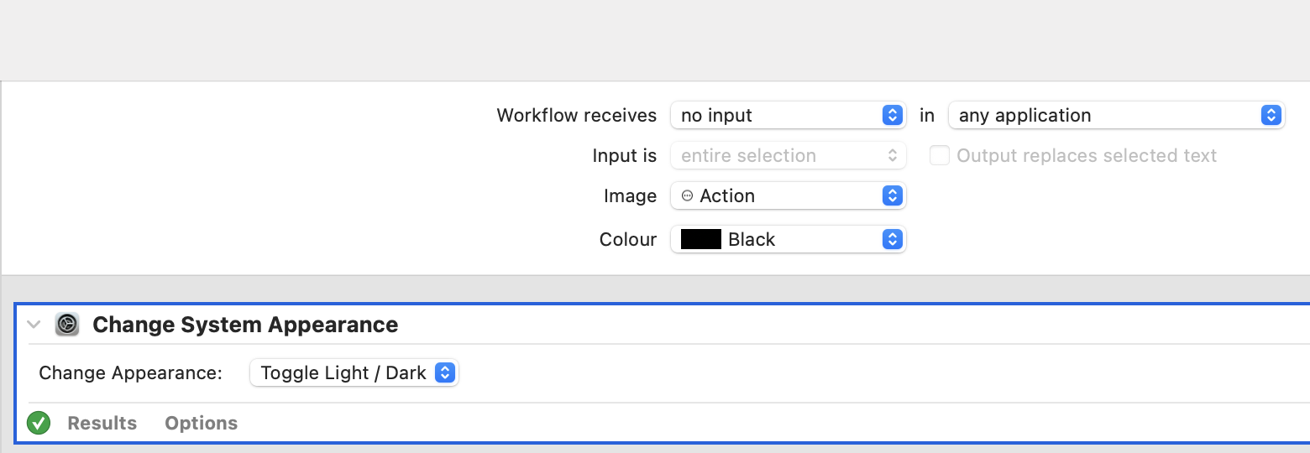

--
To create a shortcut:
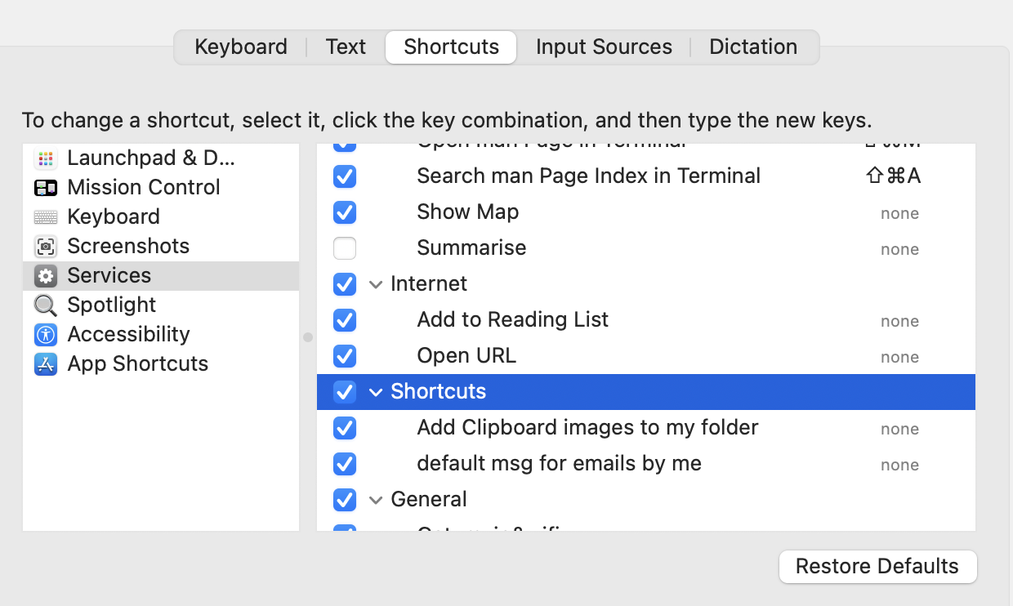

or

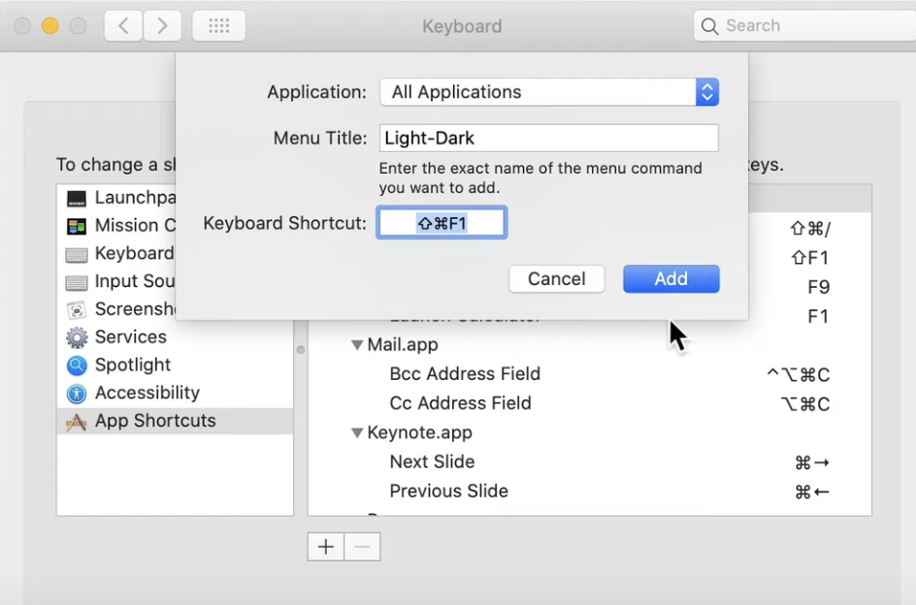

if u want that shortuct in ur dock, u need to create an application.
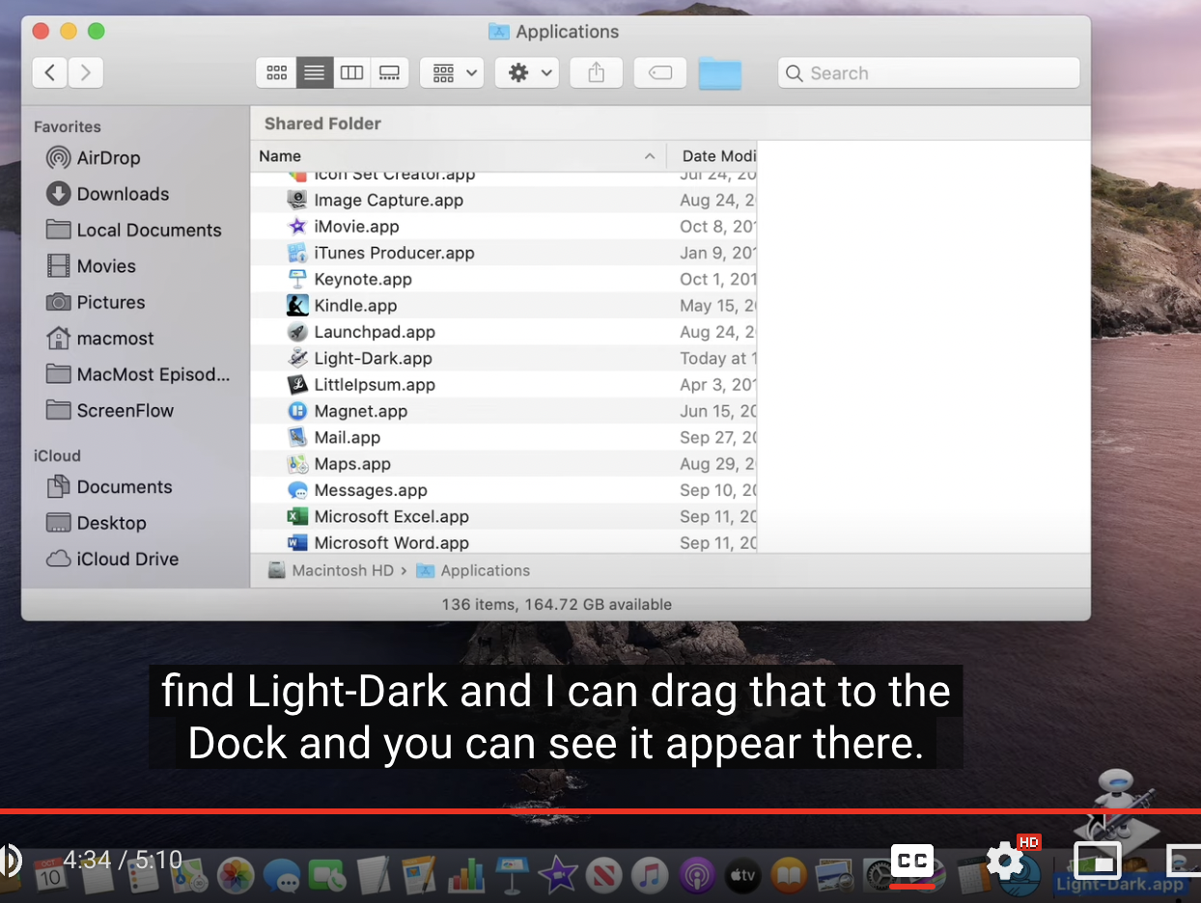Figure 2: here, in the image, the instructor drag the app to our dock to make it easily accessible.

Adding automator alarms as calendar events
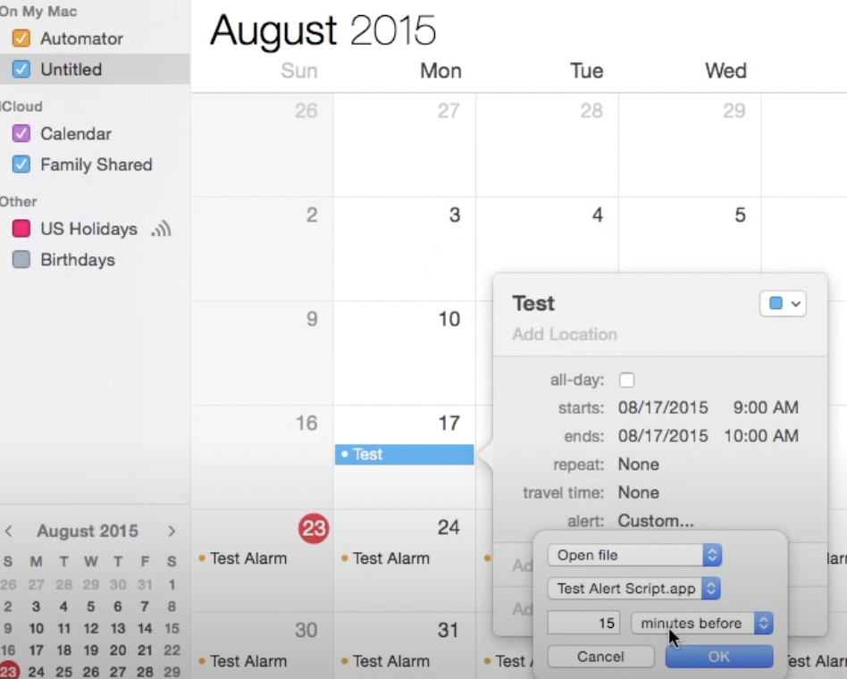Figure 3: you can run application when the calendar event is triggered.

Using automator to Playback Actions
Here we wanna print some webpage and save it to a folder named pdfs
Custom to start a workflow and then press record.
Tips:
-Avoid cursor movements, use shortcuts like shift+p to print
-Here the folder pdfs might not be in recents, so do a search. Then the automator will click on pdfs.
-Open safari from the dock
-if we use the tab instead of safari #idk mess then
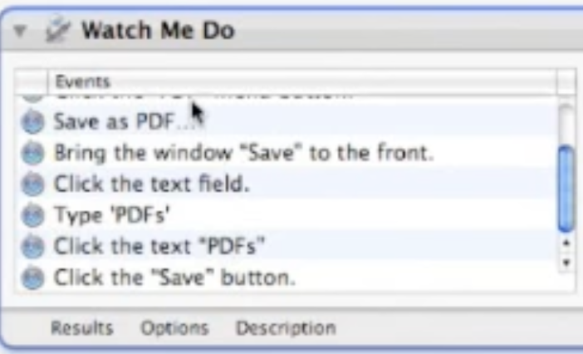
-dont drag
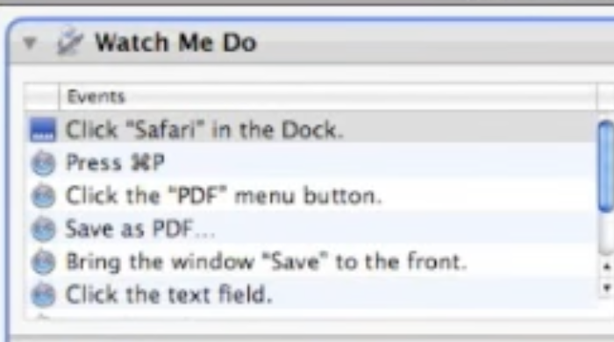

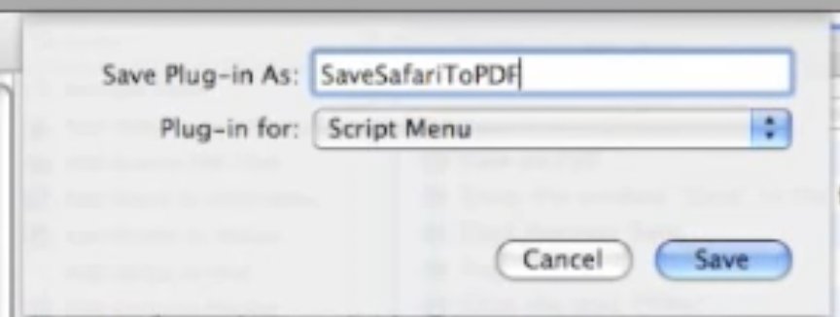

Automatically Organize Files With an Automator Folder Action Shell Script
So you can use automator to create something called folder action. This is an automator workflow that is triggered when you put a file into a folder.
One of the things that you can do with that folder, is automatically have that file move from that folder into another folder.
So you can create dropzone folder.
A folder where you can put files in it and it automatically looks at them and figures out where they need to go based on something called the filename.
Use the github link:Goto github gist.

10 Ways To Quickly Access Your Most Important Folders On a Mac
Finder:
Options+command | Create a symbolic link with a folder that is been drag.
shift+command+g | get item u like (loved it)

Terminal:
ctrl+A | to goto start of the code
ctrl+E | to goto end of the code
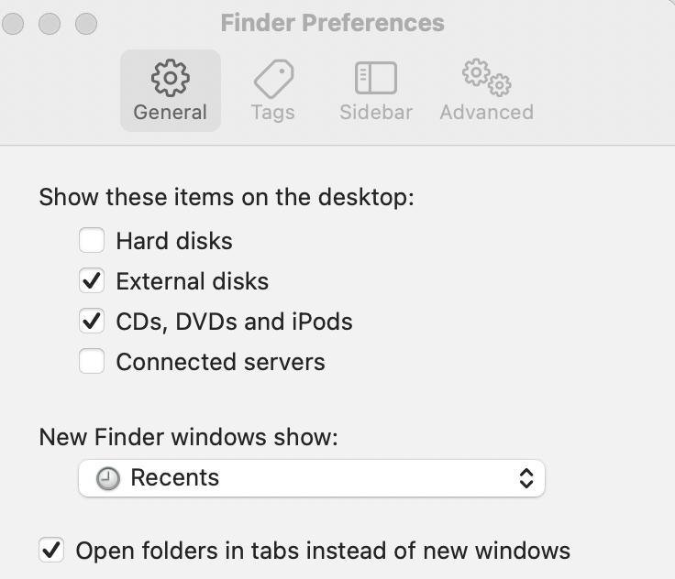Figure 4: You can also set default for ur finder window. But i prefer as it is, show me recents

3 ways to automate keystrokes
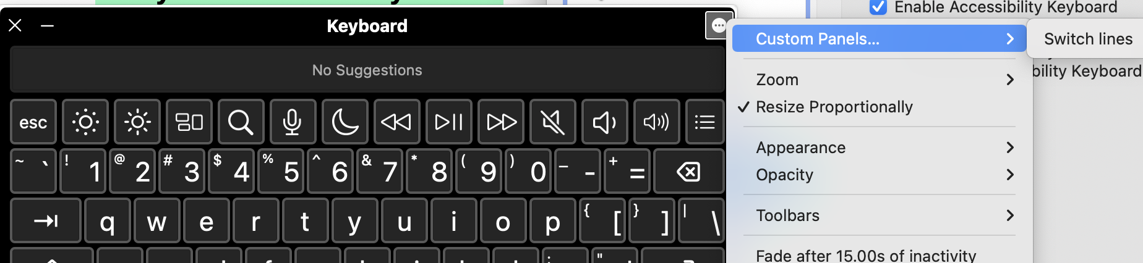
Goto accessibility → keyboard-→ panels-→ create a panel → put a button → name the pannel switch lines → click on the button and click on actions → key press → record the actions → open keyboard do the below.
And then a small gui will open with the button.
Use it and have fun.

